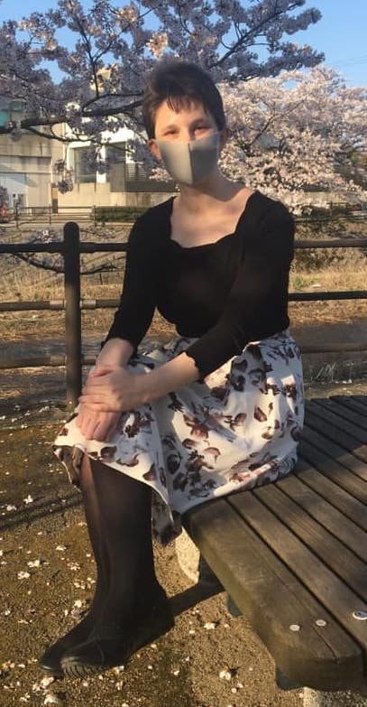
Welcome to Nishikigaoka SHS!

ALT Self-Introduction

Hello everyone! It’s nice to meet you!

Name : My name is Hannah (ハナ).

Country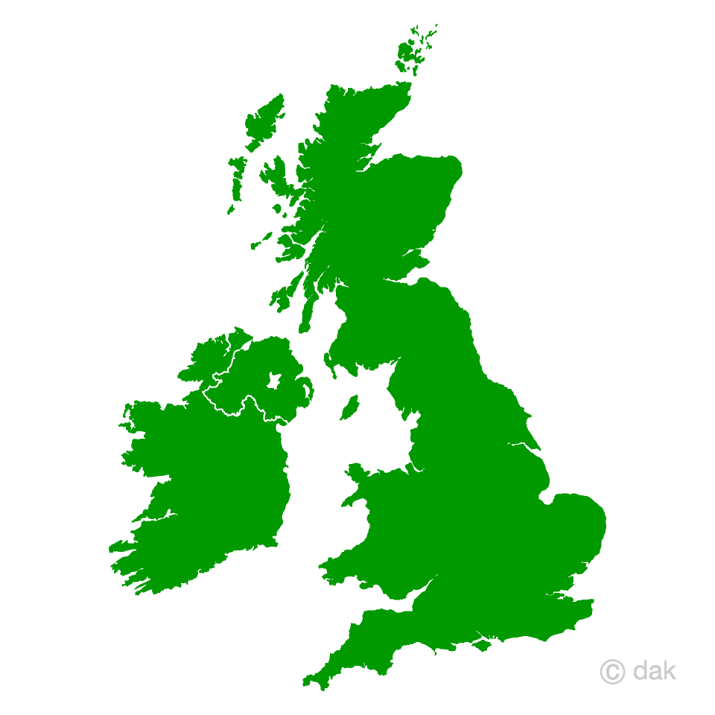:
I am from America but I have lived in Kanazawa since 2017.

Hobbies :

- My hobbies are reading books, writing stories, and hiking.
- I like listening to Twice!

Favorite Food 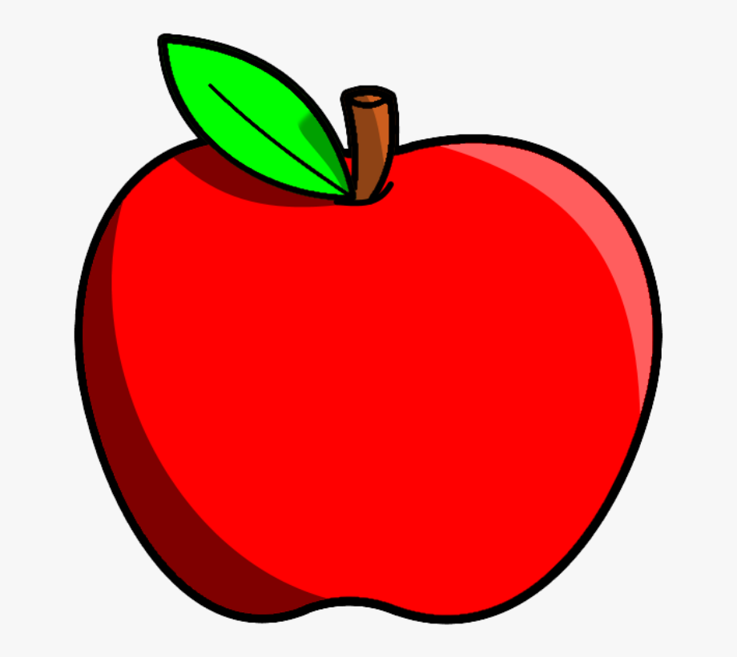:
- My favorite food is pizza.
- I also love okonomiyaki!

What is your best memory?:

My best memory is driving to Noto with my friends. We saw Senmaida and Mitsukejima. We also went swimming and saw a lot of nature. It was beautiful and relaxing!

My message:

This year in English class, I want everyone to practice speaking English! We will all make mistakes, but that’s okay. Making mistakes is GOOD for learning. Let’s speak English together soon!

